6T SRAM CELL
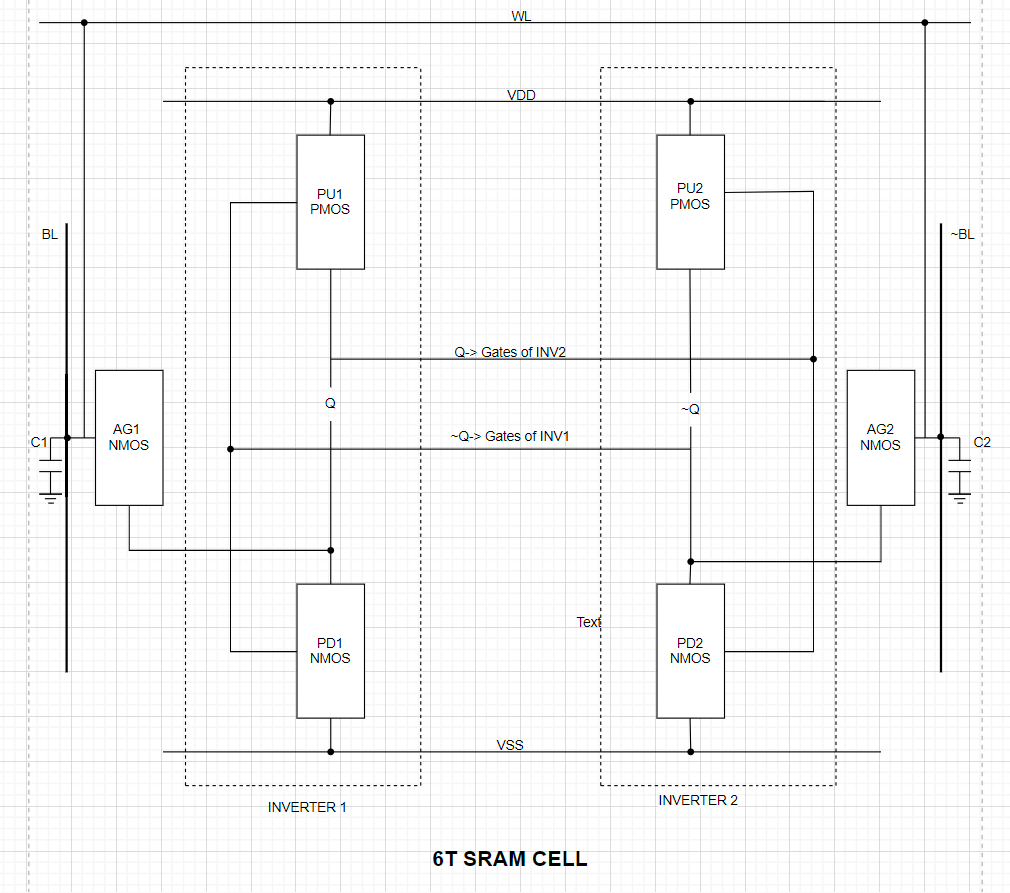
Transistor roles:
1) PU1,PU2 (Pull-Up, PMOS): drives Q,Q` to VDD, keeping logic 1
2) PD1,PD2 (Pull-Down, NMOS): drives Q,Q` to GND keeping logic 0
3) AG1, AG2 (Access Gate, NMOS): connects Q,Q` to the bit lines when WL goes high
4) C1, C2 (parasitic capacitance): used to select the operation. Not a physical capacitor but the inherent capacitance of the long bit line wires.

The memory is just the INVERTER 1 & INVERTER 2, Q and ~Q are the outputs.
If the outputs are connected to something then we can READ or WRITE what is inside the memory, so BL and ~BL is used for this, to access these lines access transistors AG1 and AG2 are used.

If WL is 1 then both AG1 & AG2 is ON and hence we can access BL and ~BL making READ & WRITE possible
If WL is 0 then both AG1 & AG2 will be OFF and hence we cannot access the bit lines making the memory go into HOLD state.
If we have to WRITE into the memory BL and ~BL will be used as input lines
If we have to READ from the memory BL and ~BL will be used as output lines
The C1 & C2 ensures both bit lines start at the same high voltage, creating a balanced state. They also act as a temporary charge reservoir

OPERATIONS:
READ:
i) Inside memory let Q=1 & ~Q=0,
ii) for read WL is asserted to 1, making the access transistors ON
iii) we can utilize the bit lines BL & ~BL. Since it is read operation bit lines should be output (discussed earlier)
iv) Now pre-charged capacitor is: VDD
v) Now, if voltage difference exists between (C1 & Q) and (C2 & ~Q),
Since we took Q=1, voltage difference between C1 & Q=0, so capacitor not discharge
Since ~Q=0, voltage difference between C2 & Q=1, so capacitor will discharge making the ~BL voltage decrease,
vi) now we send the value of BL & ~BL to the sense amplifier acting like a comparator and it will give output as 1 (if ~BL voltage decreases)

for Q=0 & Q=1 steps ii), iii), iv) remain same while v), vi) are the vice versa

WRITE:
i) Inside memory let Q=0 & ~Q=1
ii) for write WL is asserted to 1, making the access transistors ON
iii) we can utilize the bit lines BL & ~BL. Since it is write operation bit lines should be
input (discussed earlier)
iv) since bit lines are input and we have control over it we are forcing ~BL to GND,
v) now since ~Q & ~BL are connected there is a voltage difference, because of this transistors PU1 & PD 1 will be affected.
Now if V< V_{TH} of PD1 making PD1 OFF and if PD1 is OFF then PU1 will be ON making Q=1
Hence we have WRITE is successful

